A Bit on the Tesla Bot
Elon Musk is infamous for his flashy announcements, on new tech. The recent announcement of Tesla Bot at Elon Musk’s AI day is no exception. In many ways, the announcement was gimmicky, and more flash than substance. Nevertheless, if the Tesla Bot can be delivered to the specifications that were promised, it has a ton of potential. It is truly a sign of how far innovation has come.
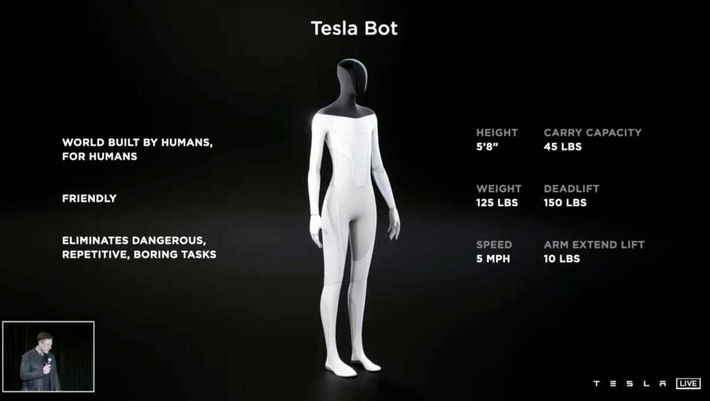
Tesla Bot - Tesla Bot: Elon Musk Reveals Humanoid Tesla Robot Which Is Apparently Not A Joke (forbes.com)
The Tesla Bot announcement was primarily concepts, with no prototype to be shown. The concept art featured a sleek, humanoid design, unlike more mechanized robots from companies like Boston Dynamics. Much of this is due to the proposed motor systems that the Tesla Bot will be using. Rather than relying on pneumatics, like Boston Dynamics, it will purely rely on electromechanical actuators (1). 40 electromechanical actuators have been announced, in total, according to Forbes: “12 in the arms, two each in the neck and torso, 12 in the legs, and 12 in the hands” (1). Due to the Tesla Bot’s proposed purpose being industrial (2), rather than for military use, it can also afford the reduction in power that electromechanical motors may create.
While Tesla Bot’s power source remains undisclosed, its proposed raw power is still nothing to scoff at. Supposedly, the robot will be able to lift 45lbs, and deadlift 150lbs (2). Moreover, it will hold this power in a small package, weighing only 125lbs and having a height of 5’8” (2).
Intimidating as the Tesla Bot may sound, the design intent is for it to be friendly to interact with. It will feature a touch screen for its face, allowing for smooth user input and interaction (1). Additionally, it will only be able to achieve speeds of 5 mph, and should be able to easily be overpowered (1). As Elon Musk put it, “We’re setting it such that it is at a mechanical level, a physical level, that you can run away from it, and most likely overpower it” (1).
When it comes to Elon Musk, it pays to take his announcements with a healthy dose of skepticism. In the same announcement panel, a person dressed in a pajama jumpsuit was used as an example of how the Tesla Bot may perform movement. Oftentimes, the products Musk winds up delivering pale in comparison to the products that he initially announced. Nevertheless, humanoid robots like the proposed Tesla Bot are technologies that have potential to become world changing. Whether Musk or another company are the first to deliver on such robots remains to be seen. In any case, humanoid robots are likely to become commonplace in the not-so-distant future. One can only hope that the people at Tesla can manage to pull their vision off.
Sources:
- Tesla Bot: Elon Musk Reveals Humanoid Tesla Robot Which Is Apparently Not A Joke (forbes.com)
- Humanoid ‘Tesla Bot’ likely to launch next year, says Elon Musk | Tesla | The Guardian

